|  |  |
| --- | --- |
| **Subject** | SWA – CS590 |
| **Assignment** | Lab 7 |
| **Date** | 8/7/2021 |
| **Students** | Vo Ngoc Huy Nguyen - 611066 |
| **Professor** | Rene de Jong |

# Lab Assignment 7: Spring Integration

**Exercise 1: Modify Spring Integration project to route 2 Channels (refer attached sources)**

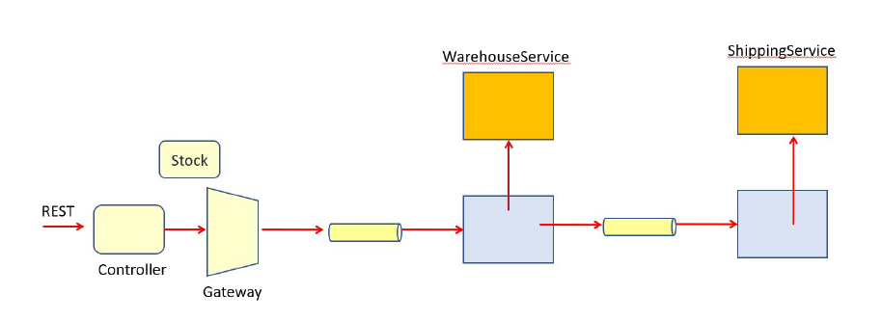

* **Structure folder:**

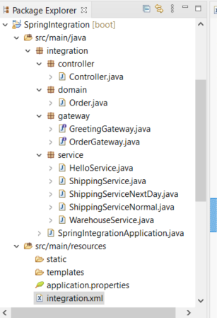

* **Integration file:**

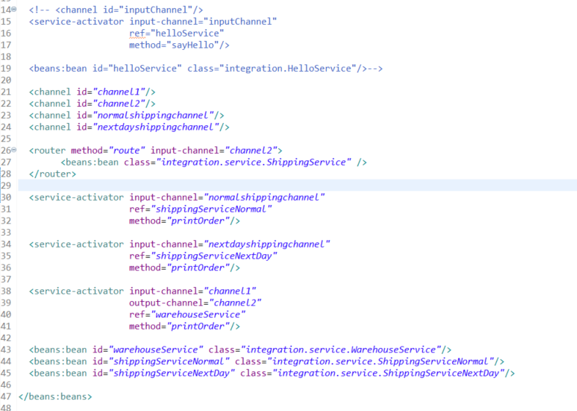

And running results:

* Normal Order

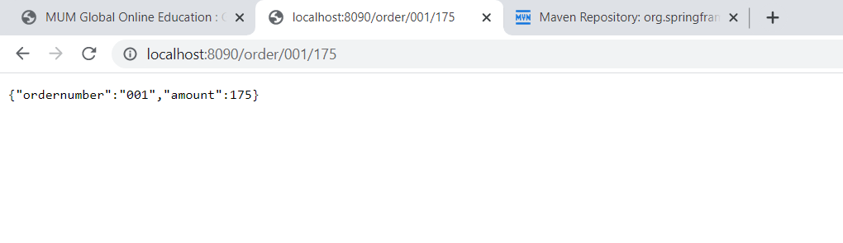

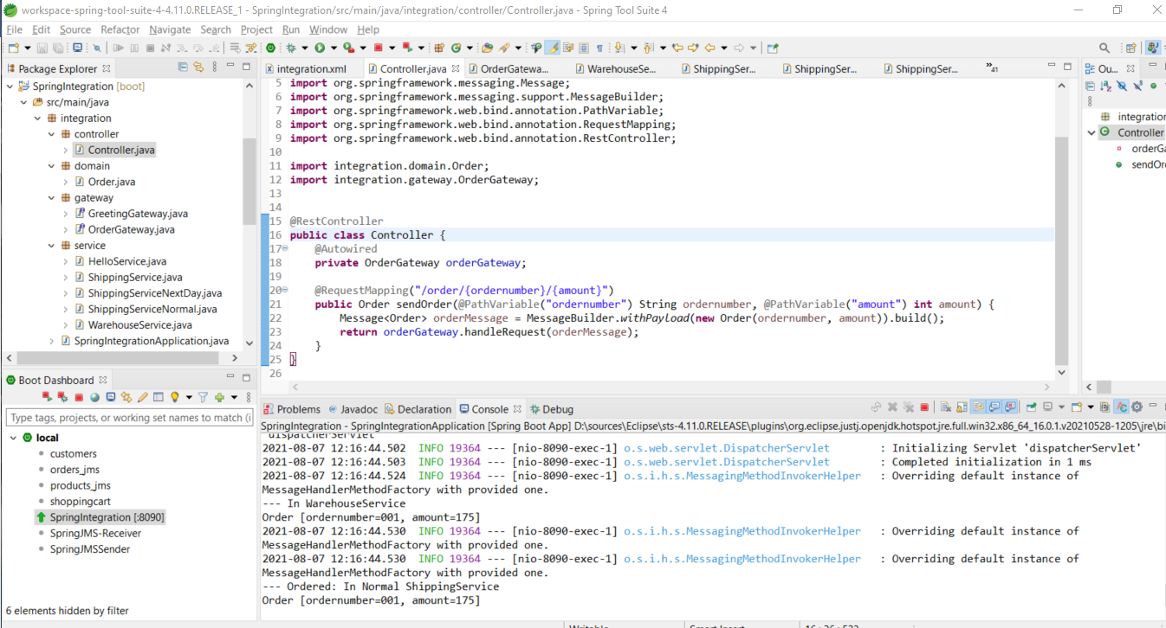

* Next day order:

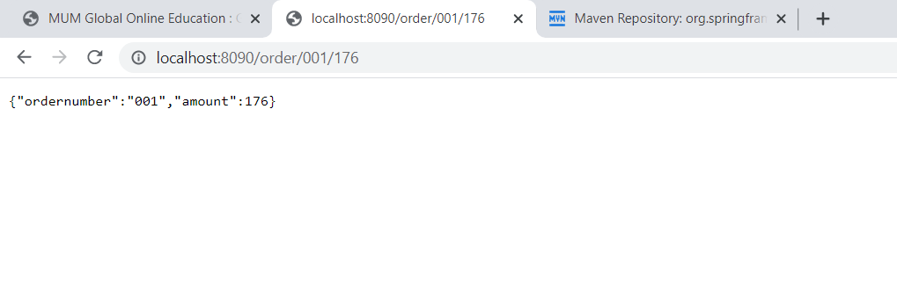

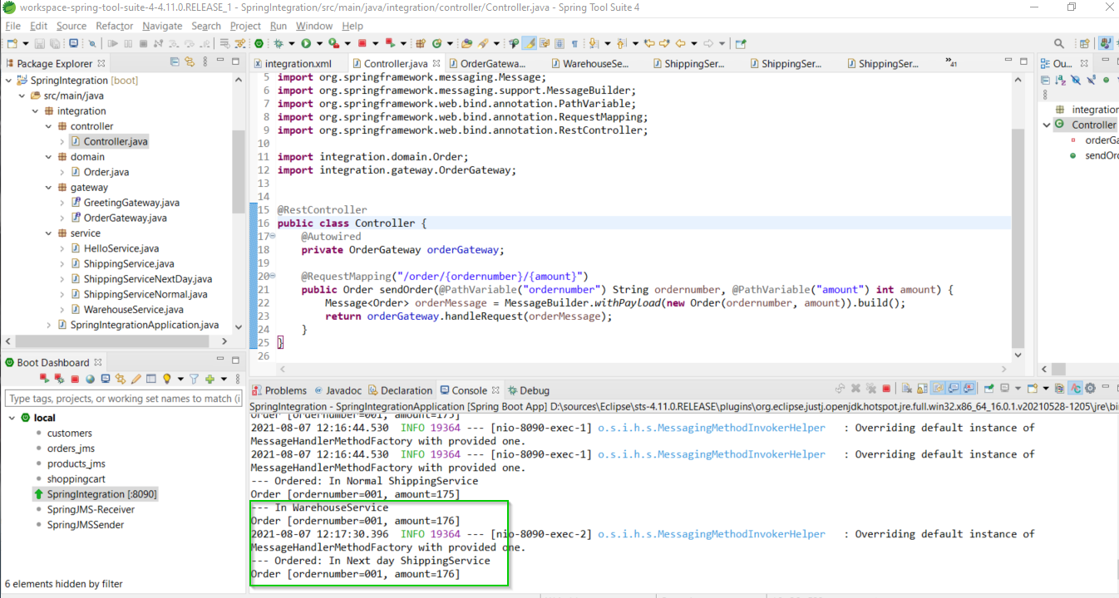

**Exercise 2: Develop application by below process and workflow:**

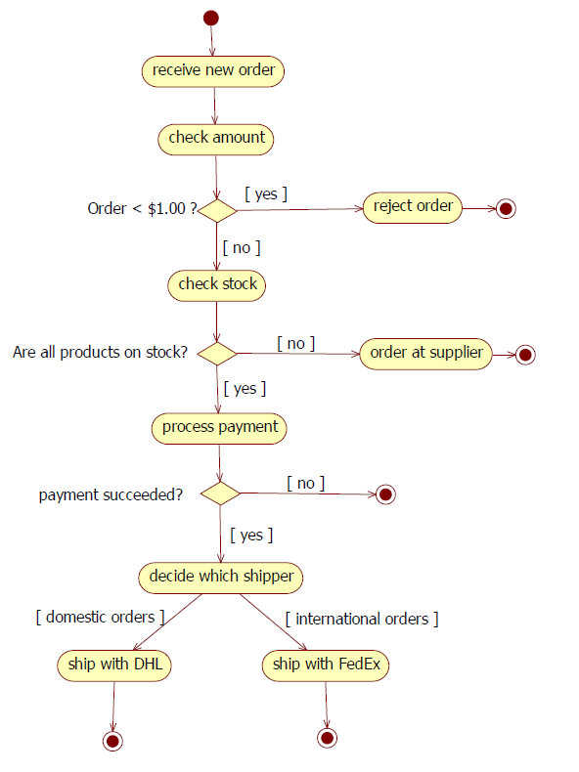

Refer bellow project structures and attached sources

